EP-PROJECT

K.L.E.F

**Green fields, Vaddeswaram, Guntur Dist**.522502

**PROJECT BASED REPORT**

**ON**

LIBRARY MANAGEMENT SYSTEM

SUBMITTED BY

|  |  |
| --- | --- |
| I.D NUMBER | NAME |
| 180030360 | K. Mohan Sai |
|  |  |

**UNDER THE GUIDANCE OF**

## N.Rajesh

**ASST.PROFESSOR**

# DEPARTMENT OF COMPUTER ENGINEERING SCIENCES

CERTIFICATE

This is to certify that the project based laboratory report entitled “**LIBRARY MANAGEMENT SYSTEM**” submitted by Mr.**K. Mohan Sai** bearing Regd. No. **180030360** to the **Department of computer Engineering Sciences, KL University** in partial fulfillment of the requirements for the completion of a project based Laboratory in “Enterprise Programming ”course in II B Tech II Semester, is a bonafide record of the work carried out by him under my supervision during the academic year 2019 – 2020.

## ACKNOWLEDGEMENTS

It is great pleasure for me to express my gratitude to our honorable President **Sri. KoneruSatyanarayana**, for giving the opportunity and platform with facilities in accomplishing the project based laboratory report.

I express the sincere gratitude to our principal **Prof** for his administration towards our academic growth.

I express sincere gratitude to HOD-CSE-1**Dr.HARI KIRAN VEGE**for his leadership and constant motivation provided in successful completion of our academic semester. I record it as my privilege to deeply thank for providing us the efficient faculty and facilities to make our ideas into reality.

I express my sincere thanks to our project supervisor **N.Rajesh Sir** for his novel association of ideas, encouragement, appreciation and intellectual zeal which motivated us to venture this project successfully.

## Finally, it is pleased to acknowledge the indebtedness to all those who devoted themselves directly or indirectly to make this project report success.

|  |  |
| --- | --- |
| I.D NUMBER | NAME |
| 180030360 | K. Mohan Sai |
|  |  |

ABSTRACT

The Library Management System provides real time information about the books available in the Library and the user information.

The main purpose of this project is to reduce the manual work.

The project is specifically designed for the use of librarians and library users.

The product will work as a complete user interface for library management process and library usage from ordinary users.

In the proposed system, we assume that each student will be having a student id which can be used for the library book issue, fine payment etc.

whenever library student wish to take a book, the book issued by the library authority will be check both the book details as well as the user details and store it in library database.

The administrator can control students and manage books.

The student’s status of issue/return is maintained in the library database.

The student’s details can be fetched by the Admin from the database as and when required.

The valid students are also allowed to view their account information

INDEX

|  |  |  |
| --- | --- | --- |
| **S.NO** | **TITLE** | **PAGE.NO** |
| 1 | Introduction | 6 |
| 2 | Proposed System | 7 |
| 2.1 | System Requirements | 8 |
| 2.2 | Description | 9-11 |
| 3 | Dataflow Diagram | 12-13 |
| 5 | Implementation | 14-44 |
| 6 | Outputs | 45-50 |
| 7 | Conclusion | 51 |

**INTRODUCTION**

The project titled Library Management System is Library management

software for monitoring and controlling the transactions in a library.The project “Library Management System” is developed in java, which mainly focuses on basic operations in a library like adding new member, new books, and updating new information, searching books and members and facility to borrow and return books. “Library Management System” is a windows application written for 32-bit Windows operating systems, designed to help users maintain and organize library. Our software is easy to use for both beginners and advanced users. It features a familiar and well thought-out, an attractive user interface, combined with strong

searching Insertion and reporting capabilities. The report generation facility of library system helps to get a good idea of which are the books borrowed by the members, makes users possible to generate reports’ hard copy.

The software Library Management System has four main modules.

* Insertion to Database Module – User friendly input screen
* Extracting from Database module – Attractive Output Screen
* Report Generation module – borrowed book list & Available book list
* Search Facility system – search for books and members

**PROPOSED SYSTEM**

Proposed system is an automated Library Management System. Through our software user can add members, add books, search members, search books, update

information, edit information, borrow and return books in quick time. Our proposed system has

the following advantages.

→ User friendly interface

→Fast access to database

→Less error

→More Storage Capacity

→Search facility

→Look and Feel Environment

→Quick transaction

All the manual difficulties in managing the Library have been rectified by implementing computerization.

**SYSTEM REQUIREMENTS**

* SOFTWARE REQUIREMENTS:

The major software requirements of the project are as follows:

Language : JAVA

Operating system **:** Windows Xp or later.

# HARDWARE REQUIREMENTS:

The hardware requirements that map towards the software are as follows: RAM :8gb

Processor :i5

**DESCRIPTION**

**Front End**

**HTML**

Hypertext Markup Language (HTML) is the standard markup language for documents designed to be displayed in a web browser. It can be assisted by technologies such as Cascading Style Sheets (CSS) and scripting languages such as JavaScript.

Web browsers receive HTML documents from a web server or from local storage and render the documents into multimedia web pages. HTML describes the structure of a web page semantically and originally included cues for the appearance of the document.

HTML elements are the building blocks of HTML pages. With HTML constructs, images and other objects such as interactive forms may be embedded into the rendered page. HTML provides a means to create structured documents by denoting structural semantics for text such as headings, paragraphs, lists, links, quotes and other items. HTML elements are delineated by tags, written using angle brackets. Tags such as <img /> and<input /> directly introduce content into the page. Other tags such as <p> surround and provide information about document text and may include other tags as sub-elements. Browsers do not display the HTML tags, but use them to interpret the content of the page. HTML can embed programs written in a scripting language such as JavaScript, which affects the behavior and content of web pages. Inclusion of CSS defines the look and layout of content. The World Wide Web Consortium (W3C), former maintainer of the HTML and current maintainer of the CSS standards, has encouraged the use of CSS over explicit presentational HTML since 1997.

**MIDDLEWARE**

**JSP**

JSP technology is used to create web application just like Servlet technology. It can be thought of as an extension to Servlet because it provides more functionality than servlet such as expression language, JSTL, etc.

A JSP page consists of HTML tags and JSP tags. The JSP pages are easier to maintain than Servlet because we can separate designing and development. It provides some additional features such as Expression Language, Custom Tags, etc.

Advantages of JSP over Servlet

There are many advantages of JSP over the Servlet. They are as follows:

1. Extension toServlet

JSP technology is the extension to Servlet technology. We can use all the features of the Servlet in JSP. In addition to, we can use implicit objects, predefined tags, expression language and Custom tags in JSP, that makes JSP development easy.

1. Easy tomaintain

JSP can be easily managed because we can easily separate our business logic with presentation logic. In Servlet technology, we mix our business logic with the presentation logic.

1. Fast Development

No need to recompile and redeploy.If JSP page is modified, we don't need to recompile and redeploy the project. The Servlet code needs to be updated and recompiled if we have to change the look and feel of the application.

**BACKEND**

Oracle database (Oracle DB) is a relational database management system (RDBMS) from the Oracle Corporation. Originally developed in 1977 by Lawrence Ellison and other developers, Oracle DB is one of the most trusted and widely-used relational database engines

The system is built around a relational database framework in which data objects may be directly accessed by users (or an application front end) through structured query language (SQL). Oracle is a fully scalable relational database architecture and is often used by global enterprises, which manage and process data across wide and local area networks. The Oracle database has its own network component to allow communications across networks.

Oracle DB is also known as Oracle RDBMS and, sometimes, just Oracle.

**IDE :-**

Eclipse is an integrated development environment (IDE) used in computer programming.[6] It contains a base workspace and an extensible plug-in system for customizing the environment. Eclipse is written mostly in Java and its primary use is for developing Java applications, but it may also be used to develop applications in other programming languages via plug-ins, including Ada, ABAP, C, C++, C#, Clojure, COBOL, D, Erlang, Fortran, Groovy, Haskell, JavaScript, Julia,[7] Lasso, Lua, NATURAL, Perl, PHP, Prolog, Python, R, Ruby (including Ruby on Rails framework), Rust, Scala, and Scheme. It can also be used to develop documents with LaTeX (via a TeXlipse plug-in) and packages for the software Mathematica. Development environments include the Eclipse Java development tools (JDT) for Java and Scala, Eclipse CDT for C/C++, and Eclipse PDT for PHP, among others.

DATAFLOW DIAGRAM

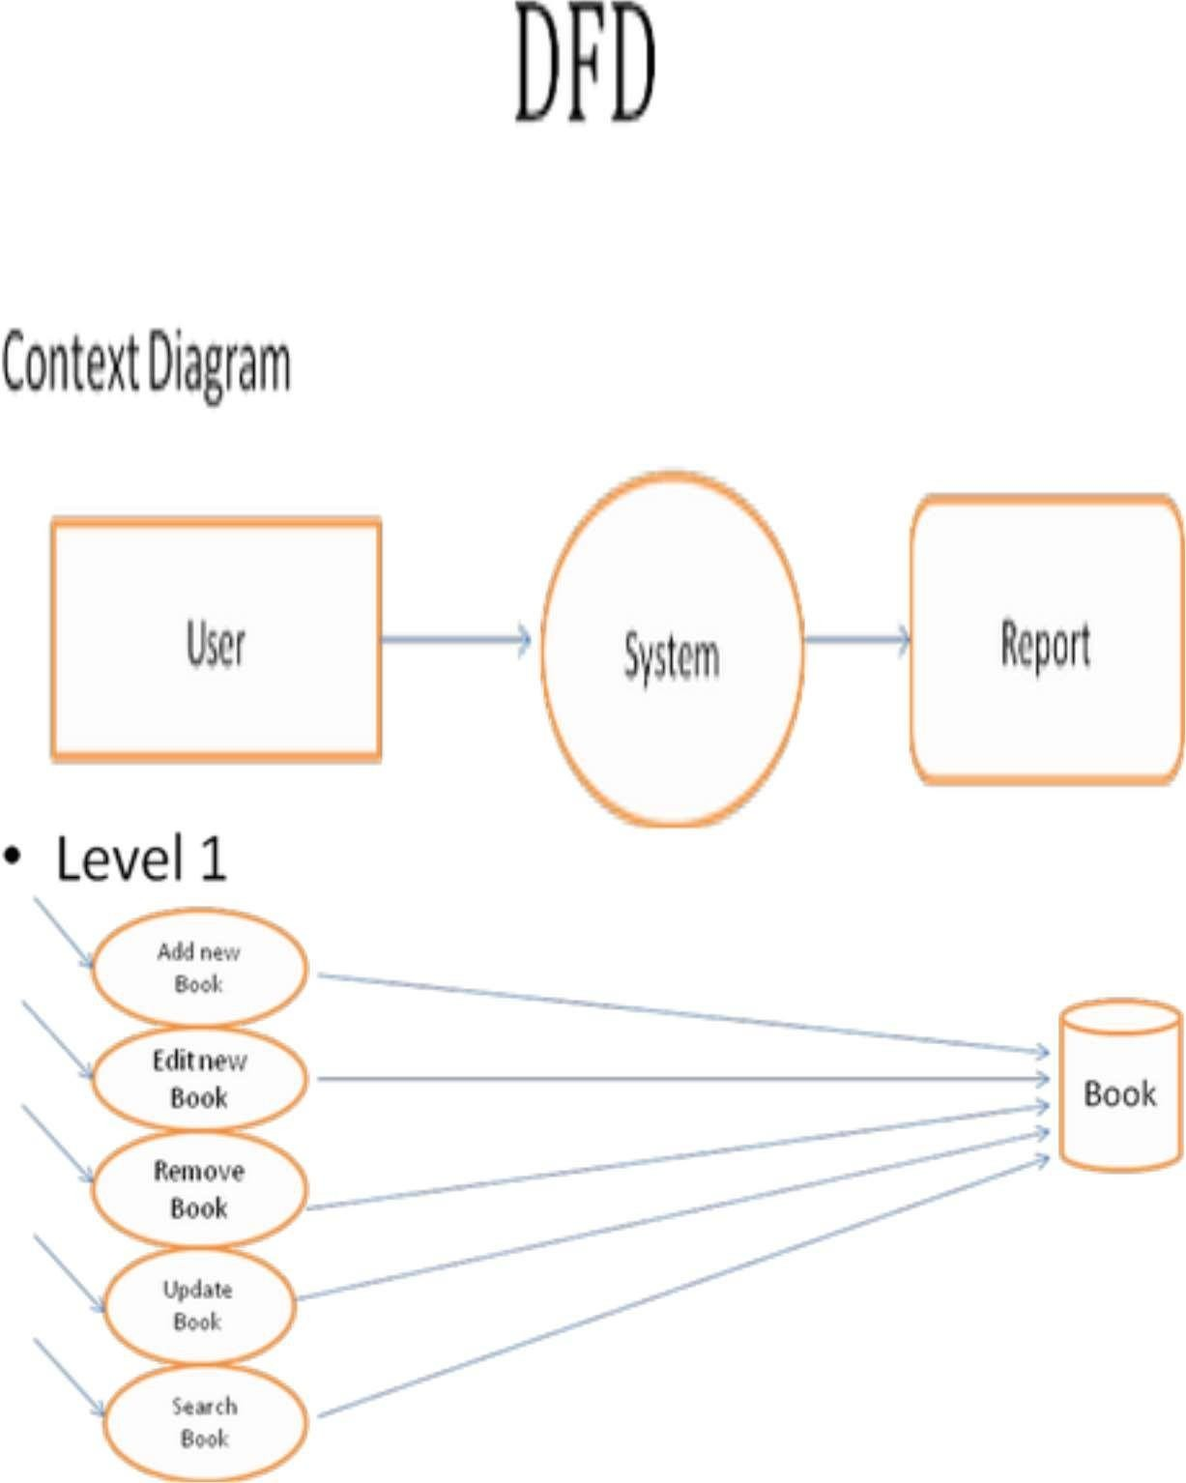

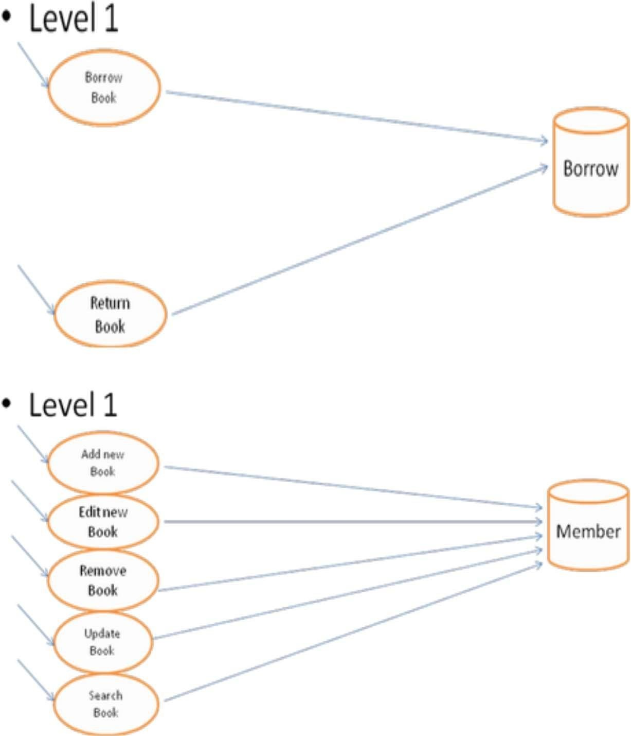

**IMPLEMENTATION**

**PROJECT.html :-**

<!DOCTYPE html>

<html>

<head>

<title>MAIN PAGE</title>

<center><h1 style="background-color:*skyblue*">LIBRARY MANAGEMENT SYSTEM</h1></center>

<body style="background-color:*yellow*">

<br><br><br><br><br><br><center><h1 style="color:*red*">WELCOME TO E-LIBRARY</h1></center>

<style>

**body** {

background-image: *url("book.jpg")*;

background-repeat: *no-repeat*;

background-attachment: *fixed*;

background-size: *cover*;

}

</style>

<br>

<br>

<br>

<marquee><image src=*"eee.jpg"* align=*"left"*width=*"300"*,height=*"300"*></marquee>

<br>

<br>

<center><a href=*"login.html"*><button style="color:*green*">CLICK HERE TO CONTINUE</button></a></center>

<br>

<br>

<br>

<br>

<br>

<br>

<br>

<br>

<center><footer style="color:*yellow*">

@ Copyrights reserved to group 24

</footer></center>

</body>

</html>

LOGIN.html :-

<!DOCTYPE html>

<html>

<head>

<title>LOGIN</title>

<center><h1 style="background-color:*skyblue*">LOGIN TO YOUR ACCOUNTS</h1></center>

<body style="background-color:*yellow*">

<style>

**body** {

background-image: *url("book1.jpg")*;

background-repeat: *no-repeat*;

background-attachment: *fixed*;

background-size: *cover*;

}

</style>

<br><br><br><br>

<marquee><image src=*"studentandfaculty.png"* align=*"left"*width=*"300"*,height=*"300"*></marquee>

<br><br><br><br><br><br><br><br>

<center><table>

<tr>

<td><image src=*"adminlogin.png"* width=*"200"*,height=*"200"*></td>

<td><center><a href=*"facultylogin.html"*><button style="color:*green*">LOGIN</button></a></center></td>

</tr>

<br>

<br>

<br>

<tr>

<td><image src=*"student-login.jpg"* width=*"200"*,height=*"200"*></td>

<td><center><a href=*"studentlogin.html"*><button style="color:*green*">LOGIN</button></a></center></td>

</tr></table>

<br>

<br>

<br>

<center><footer style="color:*yellow*">

@ Copyrights reserved to group 24

</footer></center>

</html>

FACULTYLOGIN.html :-

<!DOCTYPE html>

<html>

<head>

<title>Admin Login</title>

<center><div style="background-color: *skyblue*"><h2 style="color:*white*">Welcome To Admin Login</h2></div></center>

<br><br><br><br><br><br><br><br><br><br>

<center><fieldset style="width:*2px*"></ center>

<script type=*"text/javascript"*>

</script>

</head>

<body bgcolor=*"pink"*>

<form action=*"facultylogin.jsp"* method=*"post"*><center>

<center><table>

<tr>

<th colspan=*2*><h2 align=*center* style="color:*red*">ADMIN LOGIN</h2></th>

</tr>

<tr>

<td><label style="color:*red*">Username:</label></td><td><input type=*"text"* name=*"uname"*></td>

</tr>

<tr><td><label style="color:*red*">Password:</label></td><td><input type=*"Password"* name=*"pwd"*></td></tr>

<tr><td colspan=*"2"* align=*"center"*><input type=*"submit"* value=*"Login"* name=*"submit"*></td></tr>

<tr><td colspan=*"2"* align=*"center"* ><a href=*"facultyregister.html"* style="color:*red*">Register</a></td></tr>

</table></center>

<style>

**body** {

background-image: *url('eeeee.jpg')*;

background-repeat: *no-repeat*;

background-attachment: *fixed*;

background-size: *cover*;

}

</style>

</center>

</form>

</body></html>

FACULTYLOGIN.jsp :-

<%@ page language=*"java"* contentType=*"text/html; charset=ISO-8859-1"*

pageEncoding=*"ISO-8859-1"*%>

<!DOCTYPE html PUBLIC "-//W3C//DTD HTML 4.01 Transitional//EN" "http://www.w3.org/TR/html4/loose.dtd">

<html>

<head>

<meta http-equiv=*"Content-Type"* content=*"text/html; charset=ISO-8859-1"*>

<title>Insert title here</title>

</head>

<body>

<%@ page import=*"java.sql.*,javax.servlet.*,javax.servlet.http.*,java.io.*"*%>

<%!

Connection con;

Statement stmt;

ResultSet rs;

%>

<%

**try**{

String uname=request.getParameter("uname");

String pwd=request.getParameter("pwd");

**int** flag=0;

**int** uflag=0;

**boolean** status;

Class.forName("oracle.jdbc.driver.OracleDriver");

con=DriverManager.getConnection("jdbc:oracle:thin:@localhost:1521:xe","system","123");

PreparedStatement ps=con.prepareStatement(

"select * from facultylogin where username=? and password=?");

ps.setString(1,uname);

ps.setString(2,pwd );

ResultSet rs=ps.executeQuery();

**if**(rs.next())

{

//out.println("<h3>welcome " +" " + uname +"</h3>");

response.sendRedirect("floginafter.jsp");

session.setAttribute("uname",uname);

}

**else**

{

out.println("<center><h3>invalid username/password Enter Correct username/password</h3></center>");

}

}

**catch**(Exception e){

out.println(e);

}

%>

</body></html>

FACULTYREGISTER.html :-

<!DOCTYPE html>

<html>

<head>

<title>Admin Register</title>

<script type = *"text/javascript"*>

// Form validation code will come here.

**function** validate() {

**if**( document.myForm.name.value == "" ) {

alert( "Please provide your name!" );

document.myForm.name.focus() ;

**return** **false**;

}

**if**( document.myForm.id.value == "" ) {

alert( "Please provide your ID NO!" );

document.myForm.id.focus() ;

**return** **false**;

}

**if**( document.myForm.uname.value == "" ) {

alert( "Please provide your User Name" );

document.myForm.uname.focus() ;

**return** **false**;

}

**if**( document.myForm.pwd.value == "" ) {

alert( "Please provide your Password!" );

document.myForm.pwd.focus() ;

**return** **false**;

}

**return** **true**;

}

</script>

</head>

<center><div style="background-color: *brown*"><h2 style="color:*white*">Register As Admin</h2></div></center>

<body bgcolor=*"white"*>

<center><fieldset style="width:*4px*">

<form action=*"facultyregister.jsp"* name=*"myForm"* onsubmit="return(validate());" method=*"post"*>

<center>

<table>

<tr><td><label>Name:</label></td><td><input type=*"text"* name=*"name"*></td></tr>

<tr><td><label>ID No.:</label></td><td><input type=*"text"* name=*"id"*></td></tr>

<tr><td><label>Username:</label></td><td><input type=*"text"* name=*"uname"*></td></tr>

<tr><td><label>Password:</label></td><td><input type=*"Password"* name=*"pwd"*></td></tr>

<tr><td><label>Email:</label></td><td><input type=*"email"* name=*"email"*></td></tr>

<tr><td colspan=*"2"* align=*"center"*><input type=*"submit"* value=*"Register"* name=*"register"*></a></td></tr>

</table>

</center>

</form>

<span class=*"lgn"*>Have an account? <a href=*"facultylogin.html"*>Login</a></span>

</body></html>

FACULTYREGISTER.jsp :-

<%@ page language=*"java"* contentType=*"text/html; charset=ISO-8859-1"*

pageEncoding=*"ISO-8859-1"*%>

<%@page import=*" javax.servlet.*,*

*javax.servlet.http.*,*

*java.io.*,*

*java.sql.*"* %>

<%!

Connection con;

Statement stmt;

ResultSet rs;

%>

<%

String name = request.getParameter("name");

String id = request.getParameter("id");

String uname = request.getParameter("uname");

String pwd=request.getParameter("pwd");

String email=request.getParameter("email");

//connect with oracleDB to check whether userdetails available or not

**try**{

//connection estatblishment

Class.forName("oracle.jdbc.driver.OracleDriver");

con = DriverManager.getConnection("jdbc:oracle:thin:@localhost:1521:xe","system","123");

String st7="insert into facultydetails values(?,?,?,?,?)";

String st8="insert into facultylogin values(?,?)";

PreparedStatement ps = con.prepareStatement(st7);

ps.setString(1,name);

ps.setString(2,id);

ps.setString(3,uname);

ps.setString(4,pwd);

ps.setString(5,email);

**int** f=ps.executeUpdate();

PreparedStatement ps1 = con.prepareStatement(st8);

ps1.setString(1,uname);

ps1.setString(2,pwd);

**int** f1=ps1.executeUpdate();

out.println("<body bgcolor=#48C9B0 ><center>");

out.println("<h2>");

**if**( f>0 && f1>0){

out.println("Signup Success<br>");

out.println("Please &nbsp;&nbsp; <a href=facultylogin.html>Login</a> &nbsp;&nbsp; here");

}**else**{

out.println("Invalid Credentials<br>");

out.println("Please &nbsp;&nbsp; <a href=signup.html>Signup</a> &nbsp;&nbsp; Again");

}

out.println("</h2></center></body>");

}**catch**(Exception e){

out.println(e.getMessage());

}**finally**{

//close the connection

**try**{

con.close();

}**catch**(Exception e1){}}%>

FLOGINAFTER.jsp :-

<%@ page language=*"java"* contentType=*"text/html; charset=ISO-8859-1"*

pageEncoding=*"ISO-8859-1"*%>

<!DOCTYPE html PUBLIC "-//W3C//DTD HTML 4.01 Transitional//EN" "http://www.w3.org/TR/html4/loose.dtd">

<html>

<head>

<meta http-equiv=*"Content-Type"* content=*"text/html; charset=ISO-8859-1"*>

<title>Admin Operations</title>

</head>

<center><div style="background-color: *brown*"><h2 style="color:*white*">List Of Operations You Can Perform</h2></div></center>

<br><br><br><br><br><br><br>

<center><h1 style="color:*skyblue*"><b><i>WELCOME !!! <%=session.getAttribute("uname") %></i></b></h1></center>

<center><h1 style="color:*skyblue*"><b><i>CLICK ON THE BUTTON YOU WISH TO PERFORM</i></b></h1></center>

<body bgcolor=*"white"*>

<form action=*"redirect.jsp"* method=*"post"*>

<table align=*'center'*>

<td><input type=*"submit"* class=*"button"* name=*"x"* value=*"Add A Book"*><br><br><br></td>

<td><input type=*"submit"* class=*"button"* name=*"x"* value=*"Remove A Book"*><br><br><br></td>

<td><input type=*"submit"* class=*"button"* name=*"x"* value=*"View All Books"*><br><br><br></td>

<td><input type=*"submit"* class=*"button"* name=*"x"* value=*"Add A Student"*><br><br><br></td>

<td><input type=*"submit"* class=*"button"* name=*"x"* value=*"Remove A Student"*><br><br><br></td>

<td><input type=*"submit"* class=*"button"* name=*"x"* value=*"View Students Details"*><br><br><br></td>

<td><input type=*"submit"* class=*"button"* name=*"x"* value=*"View Student Details"*><br><br><br></td>

<tr><td><input type=*"submit"* class=*"button"* name=*"x"* value=*"View Book Requests"*><br><br><br></td></tr>

</tr>

</table>

<br><br><br><br><br><br><br><br><br>

<center><input type=*"submit"* class=*"button"* name=*"x"* value=*"Log Out"*></center><br><br><br>

</form>

</body>

<style>

*.button* {

background-color: *default*;

border: *2px solid blue*;

color: *black*;

padding: *20px 32px*;

text-align: *center*;

text-decoration: *none*;

display: *inline-block*;

font-size: *17px*;

margin: *2px 2px*;

cursor: *pointer*;

}

</style>

<style>

**body** {

background-image: *url('facultyoperations.jpg')*;

background-repeat: *no-repeat*;

background-attachment: *fixed*;

background-size: *cover*;

}

</style>

</html>

REDIRECT.jsp :-

<%@ page language=*"java"* contentType=*"text/html; charset=ISO-8859-1"*

pageEncoding=*"ISO-8859-1"*%>

<%

String x=request.getParameter("x");

**if**(x.equals("Add A Book"))

response.sendRedirect("addabook.html");

**else** **if** (x.equals("View All Books"))

response.sendRedirect("viewallbooks.jsp");

**else** **if** (x.equals("Remove A Book"))

response.sendRedirect("removebook.html");

**else** **if** (x.equals("Add A Student"))

response.sendRedirect("addstudent.html");

**else** **if** (x.equals("Remove A Student"))

response.sendRedirect("removestudent.html");

**else** **if** (x.equals("View Students Details"))

response.sendRedirect("viewallstudents.jsp");

**else** **if** (x.equals("View Student Details"))

response.sendRedirect("viewstudent.html");

**else** **if** (x.equals("View Book Requests"))

response.sendRedirect("viewbookorders.jsp");

**else** **if** (x.equals("Log Out"))

response.sendRedirect("login.html");

%>

ADDBOOK.html :-

<!DOCTYPE html>

<html>

<head>

<title>Book Details</title>

<center><h1 style="background-color:*pink*">BOOKS DETAILS</h1></center>

</head>

<body>

<body style="background-image: *url('addabook.jpg')*;background-repeat: *no-repeat*;background-size: *cover*">

<br><br><br><br><br><br><br><br><br>

<center><table>

<tr>

<th><b><form action=*"bookdetails.jsp"* method=*"post"*>Book Name:</b></th>

<td><input type=*" text"* name=*"bname"* placeholder=*"ENTER BOOK NAME"*></td>

</tr>

<tr>

<th><b>Book Id:</b></th>

<td><input type=*"text"* name=*"bid"* placeholder=*"ENTER BOOK ID"* ></td>

</tr>

<tr>

<th><b>Book Author</b></th>

<td><input type=*"text"* name=*"bauthor"* placeholder=*"ENTER BOOK AUTHOR"*></td>

</tr>

<tr>

<td colspan=*"3"* align=*"center"*><input type=*"submit"* value=*"ADD BOOK "*></td>

</tr>

</form>

</table></center>

</fieldset>

</body>

</html>

BOOKDETAILS.jsp :-

<%@ page language=*"java"* contentType=*"text/html; charset=ISO-8859-1"*

pageEncoding=*"ISO-8859-1"*%>

<%@page import=*" javax.servlet.*,*

*javax.servlet.http.*,*

*java.io.*,*

*java.sql.*"* %>

<%!

Connection con;

Statement stmt;

ResultSet rs;

%>

<% String bname = request.getParameter("bname");

String bid = request.getParameter("bid");

String bauthor = request.getParameter("bauthor");

//connect with oracleDB to check whether userdetails available or not

**try**{

//connection estatblishment

Class.forName("oracle.jdbc.driver.OracleDriver");

con = DriverManager.getConnection("jdbc:oracle:thin:@localhost:1521:xe","system","123");

String st7="insert into bookdetails values(?,?,?)";

PreparedStatement ps = con.prepareStatement(st7);

ps.setString(1,bname);

ps.setString(2,bid);

ps.setString(3,bauthor);

**int** f=ps.executeUpdate();%>

<body style="background-image: *url('addabook.jpg')*;background-repeat: *no-repeat*;background-size: *cover*"><center>

<br><br><br><br><br><br><br><br><br><br>

<%

**if**( f>0){

out.println("<b>BOOK WAS ADDED SUCCESSFULLY<b><br>");

out.println("<br><br><br><br><br>");

out.println("Press &nbsp;&nbsp; <a href=addabook.html>HERE</a> &nbsp;&nbsp; to add another book<br><br><br><br><br>");

out.println("Press &nbsp;&nbsp; <a href=floginafter.jsp>HERE</a> &nbsp;&nbsp; to return to operations page");

}**else**{

out.println("BOOK WAS NOT ADDED SUCCESSFULLY<br>");

out.println("Please &nbsp;&nbsp; <a href=addabook.html>CLICK HERE</a> &nbsp;&nbsp; to add book again");

}%>

</center></body>

<%}**catch**(Exception e){

out.println(e.getMessage());

}**finally**{

//close the connection

**try**{

con.close();

}**catch**(Exception e1){}

}%>

VIEWALLBOOKS.jsp :-

<%@page import=*"java.sql.*"*%>

<%@page import=*"java.sql.ResultSet"*%>

<%@page import=*"java.sql.Statement"*%>

<%@page import=*"java.sql.Connection"*%>

<%!

Statement stmt;

ResultSet rs;

%>

<!DOCTYPE html>

<html>

<body style="background-image: *url('addabook.jpg')*;background-repeat: *no-repeat*;background-size: *cover*">

<h1 align=*"center"*>DETAILLS OF ALL BOOKS</h1>

<br><br><br><br><br><br><br><br><br>

<center><table border=*"1"*>

<tr>

<td><lable style="color:*yellow*">BOOK NAME</lable></td>

<td><lable style="color:*yellow*">BOOK ID</lable></td>

<td><lable style="color:*yellow*">BOOK AUTHOR</lable></td>

</tr>

<%

**try**{

Class.forName("oracle.jdbc.driver.OracleDriver");

Connection con=DriverManager.getConnection("jdbc:oracle:thin:@localhost:1521:xe","system","123");

String sql ="select * from bookdetails";

PreparedStatement ps=con.prepareStatement(

"select * from bookdetails");

ResultSet rs=ps.executeQuery();

**while**(rs.next()){

%>

<tr>

<td><%=rs.getString("bName") %></td>

<td><%=rs.getString("bId") %></td>

<td><%=rs.getString("bAuthor") %></td>

</tr>

<%

}

con.close();

} **catch** (Exception e) {

e.printStackTrace();

}

%>

</table>

</body></html>

REMOVEBOOK.html :-

<!DOCTYPE html>

<html>

<head>

<meta charset=*"ISO-8859-1"*>

<title>REMOVE A BOOK</title>

</head><a><center><div style="background-color: *brown*"><h2 style="color:*white*">Remove A Book</h2></div></center></a>

<body style="background-image: *url('addabook.jpg')*;background-repeat: *no-repeat*;background-size: *cover*">

<center><form action=*"removebook.jsp"* method=*"post"*>

<br><br><br><br><br><br><br>

Enter The Id Of The Book You Want TO Remove :

<input type=*"text"* name=*"bid"* placeholder=*"Enter Book Id"*>

<br><br><br><br>

<input type=*"submit"* name=*"remove"* value=*"Remove Book"*>

</form>

</center>

</body>

</html>

REMOVEBOOK.jsp :-

<%@ page language=*"java"* contentType=*"text/html; charset=ISO-8859-1"*

pageEncoding=*"ISO-8859-1"*%>

<%@page import=*" javax.servlet.*,*

*javax.servlet.http.*,*

*java.io.*,*

*java.sql.*"* %>

<%!

Connection con;

Statement stmt;

ResultSet rs;

%>

<%

String id = request.getParameter("bid");

//connect with oracleDB to check whether userdetails available or not

**try**{

//connection estatblishment

Class.forName("oracle.jdbc.driver.OracleDriver");

con = DriverManager.getConnection("jdbc:oracle:thin:@localhost:1521:xe","system","123");

stmt = con.createStatement();

String sql = "DELETE FROM bookdetails WHERE bid = ?";

PreparedStatement ps = con.prepareStatement(sql);

ps.setString(1,id);

**int** f=ps.executeUpdate();

**if**(f>0)

{%>

<body style="background-image: *url('addabook.jpg')*;background-repeat: *no-repeat*;background-size: *cover*">

<center><h2 style="color:*red*">Book Was Deleted Successfully</h2>

<p>Press <a href=*viewallbooks.jsp* style="color:*red*">HERE</a> To View The List Of Books After Deleting</p></center>

<%

}

**else**

{%>

<body style="background-image: *url('addabook.jpg')*;background-repeat: *no-repeat*;background-size: *cover*">

<center><h2 style="color:*red*">Book Was NOT Deleted Successfully</h2>

<p>Press <a href=*removebook.html* style="color:*red*">HERE</a> To Delete Book Again</p></center>

<%

}

}**catch**(Exception e){

out.println(e.getMessage());

}**finally**{

//close the connection

**try**{

con.close();

}**catch**(Exception e1){}}%>

ADDSTUDENT.html :-

<!DOCTYPE html>

<html>

<head>

<title>Student Register</title>

<script type = *"text/javascript"*>

// Form validation code will come here.

**function** validate() {

**if**( document.myForm.name.value == "" ) {

alert( "Please provide your name!" );

document.myForm.name.focus() ;

**return** **false**;

}

**if**( document.myForm.id.value == "" ) {

alert( "Please provide your ID NO!" );

document.myForm.id.focus() ;

**return** **false**;

}

**if**( document.myForm.uname.value == "" ) {

alert( "Please provide your User Name" );

document.myForm.uname.focus() ;

**return** **false**;

}

**if**( document.myForm.pwd.value == "" ) {

alert( "Please provide your Password!" );

document.myForm.pwd.focus() ;

**return** **false**;

}

**return** **true**;

}

</script>

</head>

<center><div style="background-color: *brown*"><h2 style="color:*white*">Register As Student</h2></div></center>

<body bgcolor=*"white"*>

<center><fieldset style="width:*4px*">

<form action=*"addstudent.jsp"* name=*"myForm"* onsubmit="return(validate());" method=*"post"*>

<center>

<table>

<tr><td><label>Name:</label></td><td><input type=*"text"* name=*"name"*></td></tr>

<tr><td><label>ID No.:</label></td><td><input type=*"text"* name=*"id"*></td></tr>

<tr><td><label>Username:</label></td><td><input type=*"text"* name=*"uname"*></td></tr>

<tr><td><label>Password:</label></td><td><input type=*"Password"* name=*"pwd"*></td></tr>

<tr><td><label>Email:</label></td><td><input type=*"email"* name=*"email"*></td></tr>

<tr><td colspan=*"2"* align=*"center"*><input type=*"submit"* value=*"ADD STUDENT"* name=*"add"*></a></td></tr>

</table>

</center>

</form>

</body>

</html>

ADDSTUDENT.jsp :-

<%@ page language=*"java"* contentType=*"text/html; charset=ISO-8859-1"*

pageEncoding=*"ISO-8859-1"*%>

<%@page import=*" javax.servlet.*,*

*javax.servlet.http.*,*

*java.io.*,*

*java.sql.*"* %>

<%!

Connection con;

Statement stmt;

ResultSet rs;

%>

<% String name = request.getParameter("name");

String id = request.getParameter("id");

String uname = request.getParameter("uname");

String pwd=request.getParameter("pwd");

String email=request.getParameter("email");

//connect with oracleDB to check whether userdetails available or not

**try**{

//connection estatblishment

Class.forName("oracle.jdbc.driver.OracleDriver");

con = DriverManager.getConnection("jdbc:oracle:thin:@localhost:1521:xe","system","123");

String st7="insert into studentdetails values(?,?,?,?,?)";

String st8="insert into studentlogin values(?,?)";

PreparedStatement ps = con.prepareStatement(st7);

ps.setString(1,name);

ps.setString(2,id);

ps.setString(3,uname);

ps.setString(4,pwd);

ps.setString(5,email);

**int** f=ps.executeUpdate();

PreparedStatement ps1 = con.prepareStatement(st8);

ps1.setString(1,uname);

ps1.setString(2,pwd);

**int** f1=ps1.executeUpdate();

%>

<body style="background-image: *url('addabook.jpg')*;background-repeat: *no-repeat*;background-size: *cover*"><center>

<br><br><br><br><br><br><br><br><br><br>

<%

**if**( f>0 && f1>0){

out.println("<b>STUDENT WAS ADDED SUCCESSFULLY<b><br>");

out.println("<br><br><br><br><br>");

out.println("Press &nbsp;&nbsp; <a href=addstudent.html>HERE</a> &nbsp;&nbsp; to add another student<br><br><br><br><br>");

out.println("Press &nbsp;&nbsp; <a href=floginafter.jsp>HERE</a> &nbsp;&nbsp; to return to operations page");

}**else**{

out.println("STUDENT WAS NOT ADDED SUCCESSFULLY<br>");

out.println("Please &nbsp;&nbsp; <a href=addstudent.html>CLICK HERE</a> &nbsp;&nbsp; to add student again");

}

%>

</center></body>

<%

}**catch**(Exception e){

out.println(e.getMessage());

}**finally**{

//close the connection

**try**{

con.close();

}**catch**(Exception e1){}

}

%>

REMOVESTUDENT.html :-

<!DOCTYPE html>

<html>

<head>

<meta charset=*"ISO-8859-1"*>

<title>REMOVE A STUDENT</title>

</head><a><center><div style="background-color: *brown*"><h2 style="color:*white*">Remove A Student</h2></div></center></a>

<body style="background-image: *url('addabook.jpg')*;background-repeat: *no-repeat*;background-size: *cover*">

<center><form action=*"removestudent.jsp"* method=*"post"*>

<br><br><br><br><br><br><br>

Enter The Id Of The Student You Want TO Remove :

<input type=*"text"* name=*"sid"* placeholder=*"Enter Student Id"*>

<br><br><br><br><br><br><br>

Enter The User Name Of The Student You Want TO Remove :

<input type=*"text"* name=*"uid"* placeholder=*"Enter Student User Name"*>

<br><br><br><br>

<input type=*"submit"* name=*"remove"* value=*"Remove Student"*>

</form>

</center>

</body>

</html>

REMOVESTUDENT.jsp :-

<%@ page language=*"java"* contentType=*"text/html; charset=ISO-8859-1"*

pageEncoding=*"ISO-8859-1"*%>

<%@page import=*" javax.servlet.*,*

*javax.servlet.http.*,*

*java.io.*,*

*java.sql.*"* %>

<%!

Connection con;

Statement stmt;

ResultSet rs;

%>

<%

String id = request.getParameter("sid");

String uid = request.getParameter("uid");

//connect with oracleDB to check whether userdetails available or not

**try**{

//connection estatblishment

Class.forName("oracle.jdbc.driver.OracleDriver");

con = DriverManager.getConnection("jdbc:oracle:thin:@localhost:1521:xe","system","123");

stmt = con.createStatement();

String sql = "DELETE FROM studentdetails WHERE id = ?";

String sql1 = "DELETE FROM studentlogin WHERE username = ?";

PreparedStatement ps = con.prepareStatement(sql);

ps.setString(1,id);

**int** f=ps.executeUpdate();

PreparedStatement ps1 = con.prepareStatement(sql1);

ps1.setString(1,uid);

**int** f1=ps1.executeUpdate();

**if**(f>0 && f1>0)

{%>

<body style="background-image: *url('addabook.jpg')*;background-repeat: *no-repeat*;background-size: *cover*">

<center><h2 style="color:*red*">Student Was Deleted Successfully</h2>

<p>Press <a href=*viewallstudents.jsp* style="color:*red*">HERE</a> To View The List Of Students After Deleting</p></center>

<%

}

**else**

{%>

<body style="background-image: *url('addabook.jpg')*;background-repeat: *no-repeat*;background-size: *cover*">

<center><h2 style="color:*red*">Student Was NOT Deleted Successfully</h2>

<p>Press <a href=*removestudent.html* style="color:*red*">HERE</a> To Delete Student Again</p></center>

<%

}

}**catch**(Exception e){

out.println(e.getMessage());

}**finally**{

//close the connection

**try**{

con.close();

}**catch**(Exception e1){}

}%>

VIEWALLSTUDENTS.jsp :-

<%@page import=*"java.sql.*"*%>

<%@page import=*"java.sql.ResultSet"*%>

<%@page import=*"java.sql.Statement"*%>

<%@page import=*"java.sql.Connection"*%>

<%!

Statement stmt;

ResultSet rs;

%>

<!DOCTYPE html>

<html>

<body style="background-image: *url('addabook.jpg')*;background-repeat: *no-repeat*;background-size: *cover*">

<h1 align=*"center"*>DETAILLS OF ALL BOOKS</h1>

<br><br><br><br><br><br><br><br><br>

<center><table border=*"1"*>

<tr>

<td><lable style="color:*yellow*">STUDENT NAME</lable></td>

<td><lable style="color:*yellow*">STUDENT ID</lable></td>

<td><lable style="color:*yellow*">USERNAME</lable></td>

<td><lable style="color:*yellow*">PASSWORD</lable></td>

</tr>

<%

**try**{

Class.forName("oracle.jdbc.driver.OracleDriver");

Connection con=DriverManager.getConnection("jdbc:oracle:thin:@localhost:1521:xe","system","123");

PreparedStatement ps=con.prepareStatement(

"select * from studentdetails");

ResultSet rs=ps.executeQuery();

**while**(rs.next()){

%>

<tr>

<td><%=rs.getString(1) %></td>

<td><%=rs.getString(2) %></td>

<td><%=rs.getString(3) %></td>

<td><%=rs.getString(4) %></td>

</tr>

<%

}

con.close();

} **catch** (Exception e) {

e.printStackTrace();

}

%>

</table>

</body>

</html>

VIEWSTUDENT.html :-

<!DOCTYPE html>

<html>

<head>

<meta charset=*"ISO-8859-1"*>

<title>VIEW A STUDENT</title>

</head><a><center><div style="background-color: *brown*"><h2 style="color:*white*">STUDENT DETAILS</h2></div></center></a>

<body style="background-image: *url('addabook.jpg')*;background-repeat: *no-repeat*;background-size: *cover*">

<center><form action=*"viewstudent.jsp"* method=*"post"*>

<br><br><br><br><br><br><br>

Enter The Id Of The Student You Want To View Details :

<input type=*"text"* name=*"id"* placeholder=*"Enter Student Id"*>

<br><br><br><br>

<input type=*"submit"* name=*"view"* value=*"VIEW STUDENT DETAILS"*>

</form>

</center>

</body>

</html>

VIEWSTUDENT.jsp :-

<%@ page language=*"java"* contentType=*"text/html; charset=ISO-8859-1"*

pageEncoding=*"ISO-8859-1"*%>

<%@page import=*" javax.servlet.*,*

*javax.servlet.http.*,*

*java.io.*,*

*java.sql.*"* %>

<%!

Connection con;

Statement stmt;

ResultSet rs;

%>

<!DOCTYPE html>

<html>

<body style="background-image: *url('addabook.jpg')*;background-repeat: *no-repeat*;background-size: *cover*">

<h1 align=*"center"*>DETAILLS OF STUDENT</h1>

<br><br><br><br><br><br><br><br><br>

<center><table border=*"1"*>

<tr>

<td><lable style="color:*green*">STUDENT NAME</lable></td>

<td><lable style="color:*green*">STUDENT ID</lable></td>

<td><lable style="color:*green*">USERNAME</lable></td>

<td><lable style="color:*green*">PASSSWORD</lable></td>

</tr>

<%

String id = request.getParameter("id");

//connect with oracleDB to check whether userdetails available or not

**try**{

//connection estatblishment

Class.forName("oracle.jdbc.driver.OracleDriver");

con = DriverManager.getConnection("jdbc:oracle:thin:@localhost:1521:xe","system","123");

stmt = con.createStatement();

String sql = "SELECT * FROM studentdetails WHERE id = ?";

PreparedStatement ps = con.prepareStatement(sql);

ps.setString(1,id);

rs=ps.executeQuery();

**while**(rs.next())

{%>

<tr>

<td><%=rs.getString(1) %></td>

<td><%=rs.getString(2) %></td>

<td><%=rs.getString(3) %></td>

<td><%=rs.getString(4) %></td>

</tr>

<%

}

}**catch**(Exception e){

out.println(e.getMessage());

}**finally**{

//close the connection

**try**{

con.close();

}**catch**(Exception e1){}}%>

VIEWBOOKORDERS.jsp :-

<%@page import=*"java.sql.*"*%>

<%@page import=*"java.sql.ResultSet"*%>

<%@page import=*"java.sql.Statement"*%>

<%@page import=*"java.sql.Connection"*%>

<%!

Statement stmt;

ResultSet rs;

%>

<!DOCTYPE html>

<html>

<body style="background-image: *url('addabook.jpg')*;background-repeat: *no-repeat*;background-size: *cover*">

<h1 align=*"center"*>DEATILS OF BOOK REQUESTS</h1>

<br><br><br><br><br><br><br><br><br>

<center><table border=*"1"*>

<tr>

<td><lable style="color:*red*">STUDENT ID</lable></td>

<td><lable style="color:*red*">BOOK NAME</lable></td>

<td><lable style="color:*red*">BOOK AUTHOR</lable></td>

</tr>

<%

**try**{

Class.forName("oracle.jdbc.driver.OracleDriver");

Connection con=DriverManager.getConnection("jdbc:oracle:thin:@localhost:1521:xe","system","123");

PreparedStatement ps=con.prepareStatement(

"select * from bookrequest");

ResultSet rs=ps.executeQuery();

**while**(rs.next()){

%>

<tr>

<td><%=rs.getString(1) %></td>

<td><%=rs.getString(2) %></td>

<td><%=rs.getString(3) %></td>

</tr>

<%

}

con.close();

} **catch** (Exception e) {

e.printStackTrace();

}

%>

</table>

</body>

</html>

STUDENTLOGIN.html :-

<!DOCTYPE html>

<html>

<head>

<title>Student Login</title>

<center><div style="background-color: *skyblue*"><h2 style="color:*white*">Welcome To Student Login</h2></div></center>

<br><br><br><br><br><br><br><br><br><br>

<center><fieldset style="width:*2px*"></ center>

<script type=*"text/javascript"*>

</script>

</head>

<body bgcolor=*"pink"*>

<form action=*"studentlogin.jsp"* method=*"post"*><center>

<center><table>

<tr>

<th colspan=*2*><h2 align=*center* style="color:*red*">STUDENT LOGIN</h2></th>

</tr>

<tr>

<td><label style="color:*red*">Username:</label></td><td><input type=*"text"* name=*"uname"*></td>

</tr>

<tr><td><label style="color:*red*">Password:</label></td><td><input type=*"Password"* name=*"pwd"*></td></tr>

<tr><td colspan=*"2"* align=*"center"*><input type=*"submit"* value=*"Login"* name=*"submit"*></td></tr>

<tr><td colspan=*"2"* align=*"center"* ><a href=*"studentregister.html"* style="color:*red*">Register</a></td></tr>

</table></center>

<style>

**body** {

background-image: *url('student.jpg')*;

background-repeat: *no-repeat*;

background-attachment: *fixed*;

background-size: *100% 100%*;

}

</style>

</center>

</form>

</body>

</html>

STUDENTLOGIN.jsp :-

<%@ page language=*"java"* contentType=*"text/html; charset=ISO-8859-1"*

pageEncoding=*"ISO-8859-1"*%>

<!DOCTYPE html PUBLIC "-//W3C//DTD HTML 4.01 Transitional//EN" "http://www.w3.org/TR/html4/loose.dtd">

<html>

<head>

<meta http-equiv=*"Content-Type"* content=*"text/html; charset=ISO-8859-1"*>

<title>Insert title here</title>

</head>

<body>

<%@ page import=*"java.sql.*,javax.servlet.*,javax.servlet.http.*,java.io.*"*%>

<%!

Connection con;

Statement stmt;

ResultSet rs;

%>

<%

**try**{

String uname=request.getParameter("uname");

String pwd=request.getParameter("pwd");

**int** flag=0;

**int** uflag=0;

**boolean** status;

Class.forName("oracle.jdbc.driver.OracleDriver");

con=DriverManager.getConnection("jdbc:oracle:thin:@localhost:1521:xe","system","123");

PreparedStatement ps=con.prepareStatement(

"select * from studentlogin where username=? and password=?");

ps.setString(1,uname);

ps.setString(2,pwd );

ResultSet rs=ps.executeQuery();

**if**(rs.next())

{

response.sendRedirect("sloginafter.jsp");

session.setAttribute("uname",uname);

}

**else**

{

out.println("<center><h3>invalid username/password Enter Correct username/password</h3></center>");

}

}

**catch**(Exception e){

out.println(e);

}

%>

</body>

</html>

STUDENTREGISTER.html :-

<!DOCTYPE html>

<html>

<head>

<title>Student Register</title>

<script type = *"text/javascript"*>

// Form validation code will come here.

**function** validate() {

**if**( document.myForm.name.value == "" ) {

alert( "Please provide your name!" );

document.myForm.name.focus() ;

**return** **false**;

}

**if**( document.myForm.id.value == "" ) {

alert( "Please provide your ID NO!" );

document.myForm.id.focus() ;

**return** **false**;

}

**if**( document.myForm.uname.value == "" ) {

alert( "Please provide your User Name" );

document.myForm.uname.focus() ;

**return** **false**;

}

**if**( document.myForm.pwd.value == "" ) {

alert( "Please provide your Password!" );

document.myForm.pwd.focus() ;

**return** **false**;

}

**return** **true**;

}

</script>

</head>

<center><div style="background-color: *brown*"><h2 style="color:*white*">Register As Student</h2></div></center>

<body bgcolor=*"white"*>

<center><fieldset style="width:*4px*">

<form action=*"studentregister.jsp"* name=*"myForm"* onsubmit="return(validate());" method=*"post"*>

<center>

<table>

<tr><td><label>Name:</label></td><td><input type=*"text"* name=*"name"*></td></tr>

<tr><td><label>ID No.:</label></td><td><input type=*"text"* name=*"id"*></td></tr>

<tr><td><label>Username:</label></td><td><input type=*"text"* name=*"uname"*></td></tr>

<tr><td><label>Password:</label></td><td><input type=*"Password"* name=*"pwd"*></td></tr>

<tr><td><label>Email:</label></td><td><input type=*"email"* name=*"email"*></td></tr>

<tr><td colspan=*"2"* align=*"center"*><input type=*"submit"* value=*"Register"* name=*"register"*></a></td></tr>

</table>

</center>

</form>

<span class=*"lgn"*>Have an account? <a href=*"studentlogin.html"*>Login</a></span>

</body>

</html>

STUDENTREGISTER.jsp :-

<%@ page language=*"java"* contentType=*"text/html; charset=ISO-8859-1"*

pageEncoding=*"ISO-8859-1"*%>

<%@page import=*" javax.servlet.*,*

*javax.servlet.http.*,*

*java.io.*,*

*java.sql.*"* %>

<%!

Connection con;

Statement stmt;

ResultSet rs;

%>

<% String name = request.getParameter("name");

String id = request.getParameter("id");

String uname = request.getParameter("uname");

String pwd=request.getParameter("pwd");

//connect with oracleDB to check whether userdetails available or not

**try**{

//connection estatblishment

Class.forName("oracle.jdbc.driver.OracleDriver");

con = DriverManager.getConnection("jdbc:oracle:thin:@localhost:1521:xe","system","123");

String st7="insert into studentdetails values(?,?,?,?)";

String st8="insert into studentlogin values(?,?)";

PreparedStatement ps = con.prepareStatement(st7);

ps.setString(1,name);

ps.setString(2,id);

ps.setString(3,uname);

ps.setString(4,pwd);

**int** f=ps.executeUpdate();

PreparedStatement ps1 = con.prepareStatement(st8);

ps1.setString(1,uname);

ps1.setString(2,pwd);

**int** f1=ps1.executeUpdate();

out.println("<body bgcolor=#48C9B0 ><center>");

out.println("<h2>");

**if**( f>0 && f1>0){

out.println("Signup Success<br>");

out.println("Please &nbsp;&nbsp; <a href=studentlogin.html>Login</a> &nbsp;&nbsp; here");

}**else**{

out.println("Invalid Credentials<br>");

out.println("Please &nbsp;&nbsp; <a href=signup.html>Signup</a> &nbsp;&nbsp; Again");

}

out.println("</h2></center></body>");

}**catch**(Exception e){

out.println(e.getMessage());

}**finally**{

//close the connection

**try**{con.close();}**catch**(Exception e1){}}%>

SLOGIN.jsp :-

<%@ page language=*"java"* contentType=*"text/html; charset=ISO-8859-1"*

pageEncoding=*"ISO-8859-1"*%>

<!DOCTYPE html PUBLIC "-//W3C//DTD HTML 4.01 Transitional//EN" "http://www.w3.org/TR/html4/loose.dtd">

<html>

<head>

<meta http-equiv=*"Content-Type"* content=*"text/html; charset=ISO-8859-1"*>

<title>Student Operations</title>

</head>

<center><div style="background-color: *brown*"><h2 style="color:*white*">List Of Operations You Can Perform</h2></div></center>

<br><br><br><br><br><br><br>

<center><h1 style="color:*white*"><b><i>WELCOME !!! <%=session.getAttribute("uname") %></i></b></h1></center>

<center><h1 style="color:*white*"><b><i>CLICK ON THE BUTTON YOU WISH TO PERFORM</i></b></h1></center>

<body bgcolor=*"white"*>

<form action=*"sredirect.jsp"* method=*"post"*>

<table align=*'center'*>

<tr>

<td><input type=*"submit"* class=*"button"* name=*"x"* value=*"View All Books"*><br><br><br></td>

<td><input type=*"submit"* class=*"button"* name=*"x"* value=*"Request A Book"*><br><br><br></td>

<td><input type=*"submit"* class=*"button"* name=*"x"* value=*"View Students Details"*><br><br><br></td>

<td><input type=*"submit"* class=*"button"* name=*"x"* value=*"Log Out"*><br><br><br></td>

</tr>

</table>

</form>

</body>

<style>

*.button* {

background-color: *default*;

border: *2px solid blue*;

color: *black*;

padding: *20px 32px*;

text-align: *center*;

text-decoration: *none*;

display: *inline-block*;

font-size: *17px*;

margin: *2px 2px*;

cursor: *pointer*;

}

</style>

<style>

**body** {

background-image: *url('sloginafter.jpg')*;

background-repeat: *no-repeat*;

background-attachment: *fixed*;

background-size: *cover*;

}

</style>

</html>

SLOGINAFTER.jsp :-

<%@ page language=*"java"* contentType=*"text/html; charset=ISO-8859-1"*

pageEncoding=*"ISO-8859-1"*%>

<!DOCTYPE html PUBLIC "-//W3C//DTD HTML 4.01 Transitional//EN" "http://www.w3.org/TR/html4/loose.dtd">

<html>

<head>

<meta http-equiv=*"Content-Type"* content=*"text/html; charset=ISO-8859-1"*>

<title>Student Operations</title>

</head>

<center><div style="background-color: *brown*"><h2 style="color:*white*">List Of Operations You Can Perform</h2></div></center>

<br><br><br><br><br><br><br>

<center><h1 style="color:*white*"><b><i>WELCOME !!! <%=session.getAttribute("uname") %></i></b></h1></center>

<center><h1 style="color:*white*"><b><i>CLICK ON THE BUTTON YOU WISH TO PERFORM</i></b></h1></center>

<body bgcolor=*"white"*>

<form action=*"sredirect.jsp"* method=*"post"*>

<table align=*'center'*>

<tr>

<td><input type=*"submit"* class=*"button"* name=*"x"* value=*"View All Books"*><br><br><br></td>

<td><input type=*"submit"* class=*"button"* name=*"x"* value=*"Request A Book"*><br><br><br></td>

<td><input type=*"submit"* class=*"button"* name=*"x"* value=*"View Students Details"*><br><br><br></td>

<td><input type=*"submit"* class=*"button"* name=*"x"* value=*"Log Out"*><br><br><br></td>

</tr>

</table>

</form>

</body>

<style>

*.button* {

background-color: *default*;

border: *2px solid blue*;

color: *black*;

padding: *20px 32px*;

text-align: *center*;

text-decoration: *none*;

display: *inline-block*;

font-size: *17px*;

margin: *2px 2px*;

cursor: *pointer*;

}

</style>

<style>

**body** {

background-image: *url('sloginafter.jpg')*;

background-repeat: *no-repeat*;

background-attachment: *fixed*;

background-size: *cover*;

}

</style>

</html>

SREDIRECT.jsp :-

<%@ page language=*"java"* contentType=*"text/html; charset=ISO-8859-1"*

pageEncoding=*"ISO-8859-1"*%>

<%

String x=request.getParameter("x");

**if** (x.equals("View All Books"))

response.sendRedirect("viewallbooks.jsp");

**if** (x.equals("Request A Book"))

response.sendRedirect("requestbook.html");

**else** **if** (x.equals("View Students Details"))

response.sendRedirect("sviewallstudents.jsp");

**else** **if** (x.equals("Log Out"))

response.sendRedirect("login.html");

%>

REQUESTBOOK.html :-

<!DOCTYPE html>

<html>

<head>

<title>Book Request</title>

<center><h1 style="background-color:*pink*">REQUEST A BOOK</h1></center>

</head>

<body>

<body style="background-image: *url('sloginafter.jpg')*;background-repeat: *no-repeat*;background-size: *cover*">

<br><br><br><br><br><br><br><br><br>

<center><table>

<tr>

<th><b><form action=*"requestbook.jsp"* method=*"post"*><lable for=*"sid"* style="color:*red*">STUDENT ID:</b></th>

<td><input type=*" text"* name=*"sid"* placeholder=*"ENTER YOUR ID"*></td>

</tr>

<tr>

<th><lable for=*"bname"* style="color:*red*"><b>Book Name:</b></th>

<td><input type=*" text"* name=*"bname"* placeholder=*"ENTER BOOK NAME"*></td>

</tr>

<tr>

<th><lable for=*"bauthor"* style="color:*red*"><b>Book Author</b></th>

<td><input type=*"text"* name=*"bauthor"* placeholder=*"ENTER BOOK AUTHOR"*></td>

</tr>

<tr>

<td colspan=*"3"* align=*"center"*><input type=*"submit"* value=*"REQUEST BOOK "*></td>

</tr>

</form>

</table></center>

</fieldset>

</body>

</html>

REQUESTBOOK.jsp :-

<%@ page language=*"java"* contentType=*"text/html; charset=ISO-8859-1"*

pageEncoding=*"ISO-8859-1"*%>

<%@page import=*" javax.servlet.*,*

*javax.servlet.http.*,*

*java.io.*,*

*java.sql.*"* %>

<%!

Connection con;

Statement stmt;

ResultSet rs;

%>

<% String sid = request.getParameter("sid");

String bname = request.getParameter("bname");

String bauthor = request.getParameter("bauthor");

//connect with oracleDB to check whether userdetails available or not

**try**{

//connection estatblishment

Class.forName("oracle.jdbc.driver.OracleDriver");

con = DriverManager.getConnection("jdbc:oracle:thin:@localhost:1521:xe","system","123");

String st7="insert into bookrequest values(?,?,?)";

PreparedStatement ps = con.prepareStatement(st7);

ps.setString(1,sid);

ps.setString(2,bname);

ps.setString(3,bauthor);

**int** f=ps.executeUpdate();%>

<body style="background-image: *url('addabook.jpg')*;background-repeat: *no-repeat*;background-size: *cover*"><center>

<br><br><br><br><br><br><br><br><br><br>

<%

**if**( f>0){

out.println("<b>YOUR REQUEST WAS SUCCESSFULLY SAVED<b><br>");

out.println("<br><br><br><br><br>");

out.println("Press &nbsp;&nbsp; <a href=request.html>HERE</a> &nbsp;&nbsp; to request another book<br><br><br><br><br>");

out.println("Press &nbsp;&nbsp; <a href=sloginafter.jsp>HERE</a> &nbsp;&nbsp; to return to operations page");

}**else**{

out.println("YOUR REQUEST WAS NOT SUCCESSFULLY SAVED<br>");

out.println("Please &nbsp;&nbsp; <a href=requestbook.html>CLICK HERE</a> &nbsp;&nbsp; to request book again");

}%>

</center></body>

<%}**catch**(Exception e){

out.println(e.getMessage());

}**finally**{

//close the connection

**try**{

con.close();

}**catch**(Exception e1){}

}%>

SVIEWALLSTUDENTS.jsp :-

<%@page import=*"java.sql.*"*%>

<%@page import=*"java.sql.ResultSet"*%>

<%@page import=*"java.sql.Statement"*%>

<%@page import=*"java.sql.Connection"*%>

<%!

Statement stmt;

ResultSet rs;

%>

<!DOCTYPE html>

<html>

<body style="background-image: *url('addabook.jpg')*;background-repeat: *no-repeat*;background-size: *cover*">

<h1 align=*"center"*>DETAILLS OF ALL BOOKS</h1>

<br><br><br><br><br><br><br><br><br>

<center><table border=*"1"*>

<tr>

<td><lable style="color:*yellow*">STUDENT NAME</lable></td>

<td><lable style="color:*yellow*">STUDENT ID</lable></td>

</tr>

<%

**try**{

Class.forName("oracle.jdbc.driver.OracleDriver");

Connection con=DriverManager.getConnection("jdbc:oracle:thin:@localhost:1521:xe","system","123");

PreparedStatement ps=con.prepareStatement(

"select * from studentdetails");

ResultSet rs=ps.executeQuery();

**while**(rs.next()){

%>

<tr>

<td><%=rs.getString(1) %></td>

<td><%=rs.getString(2) %></td>

</tr>

<%

}

con.close();

} **catch** (Exception e) {

e.printStackTrace();

}

%>

</table>

</body>

</html>

**OUTPUTS**

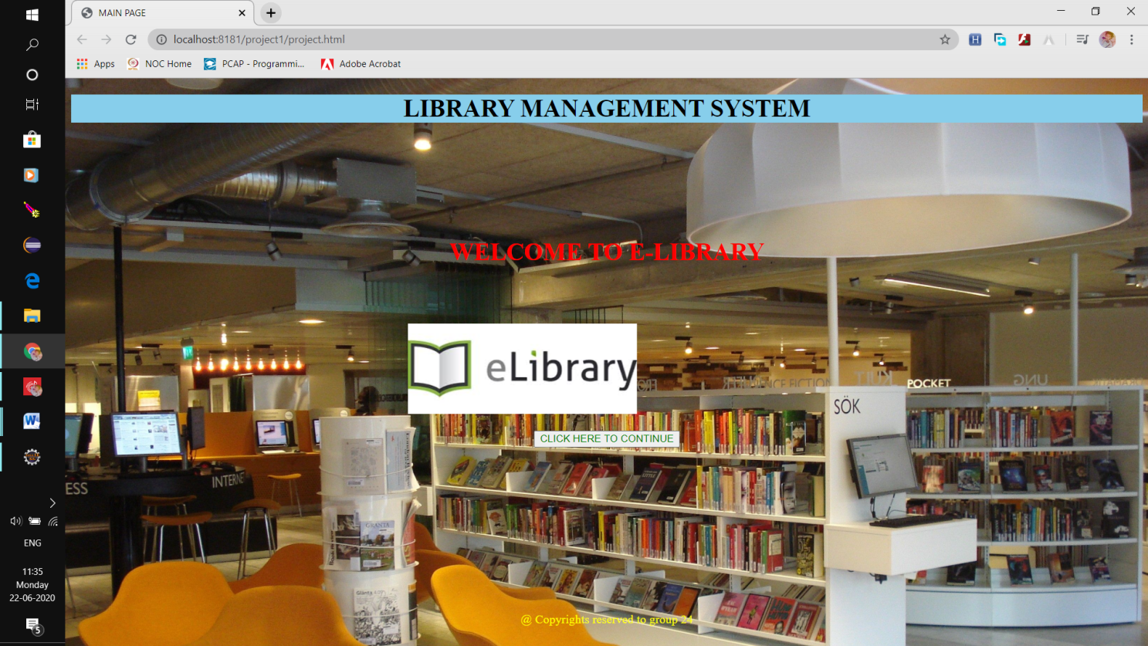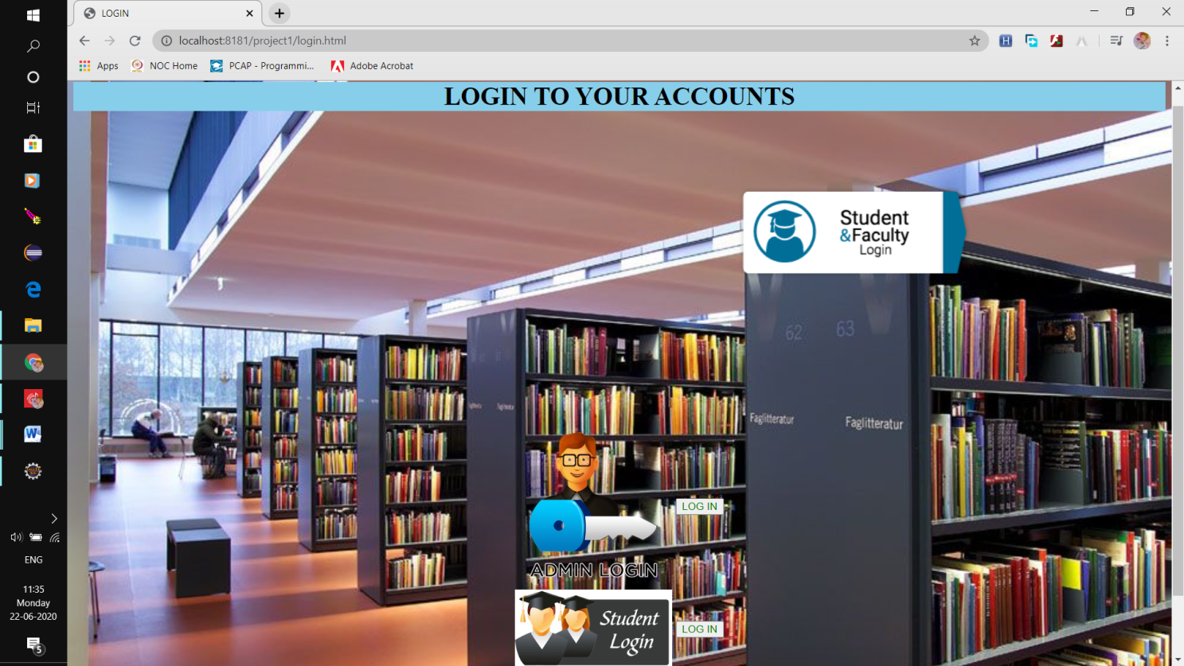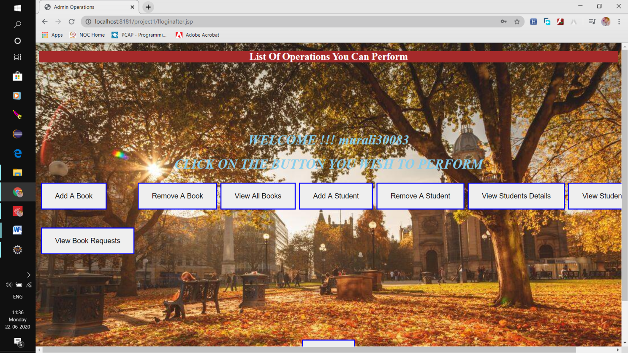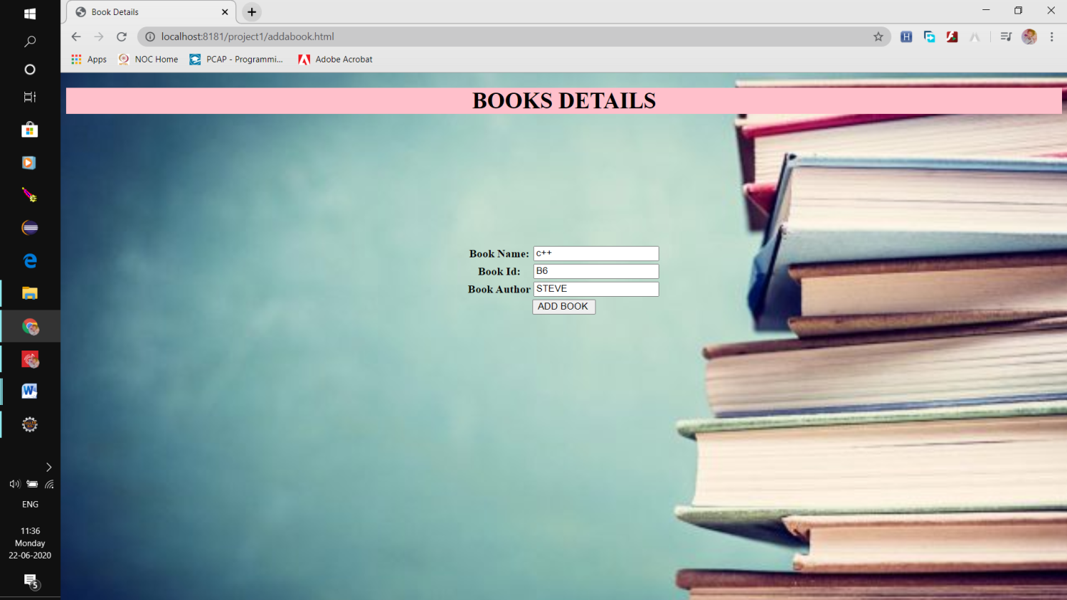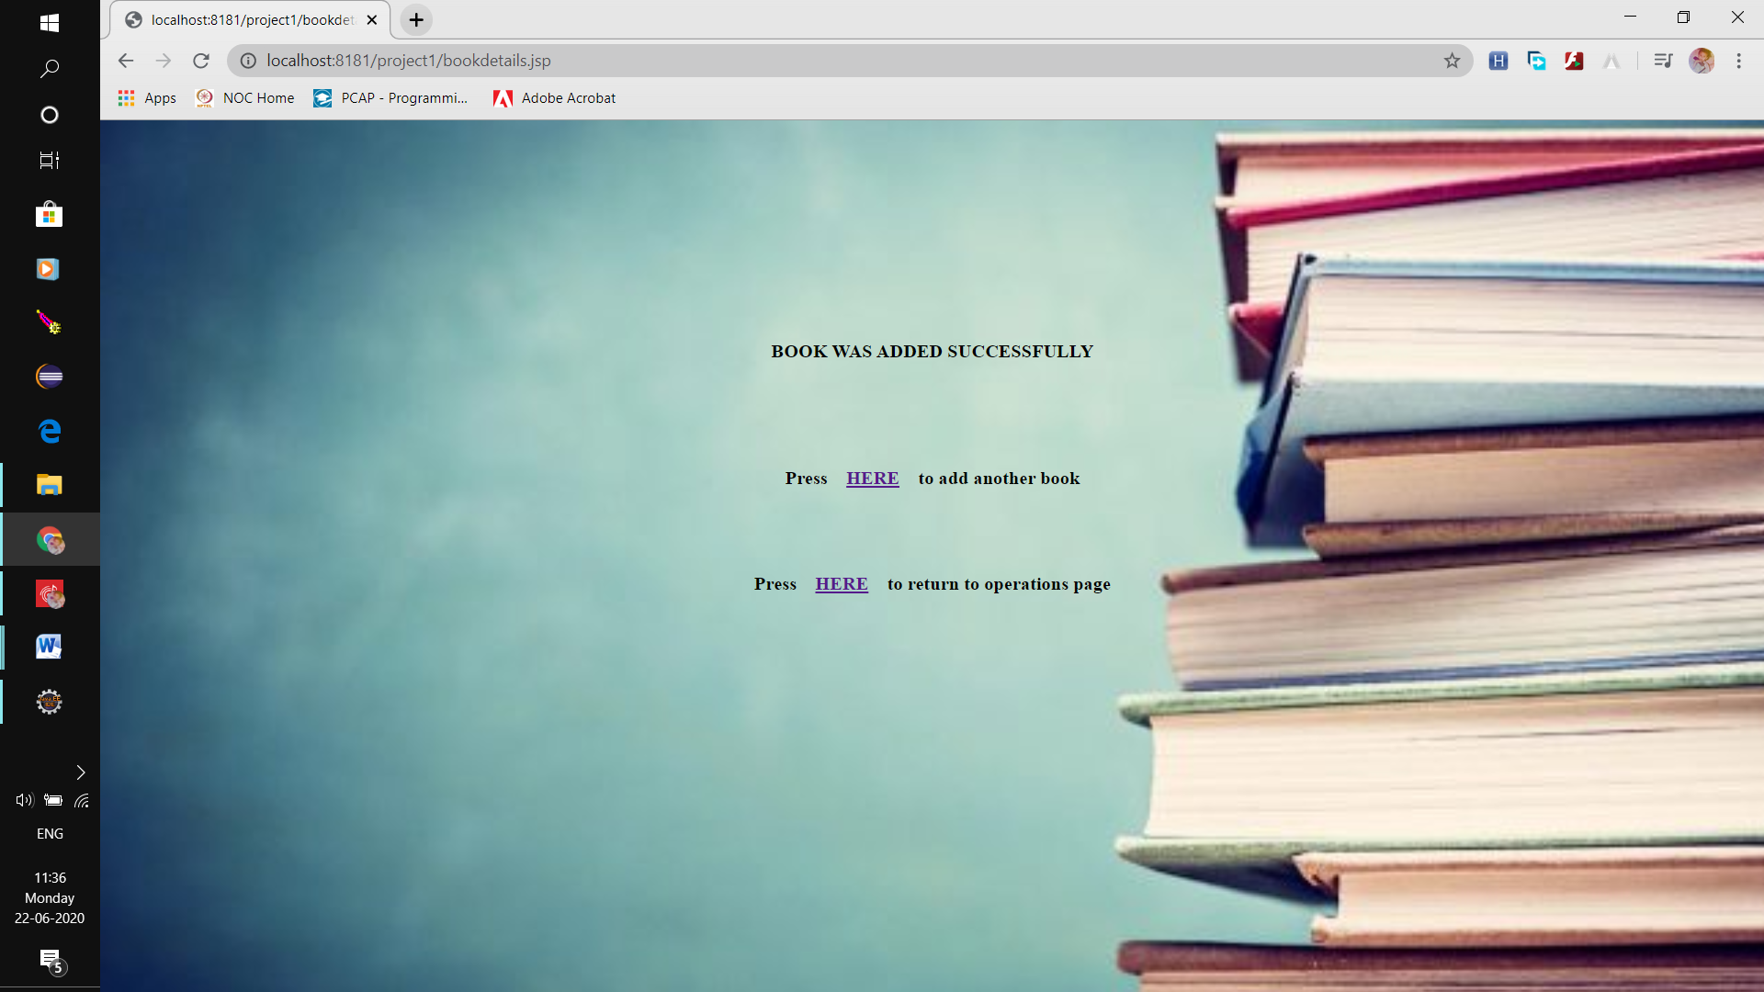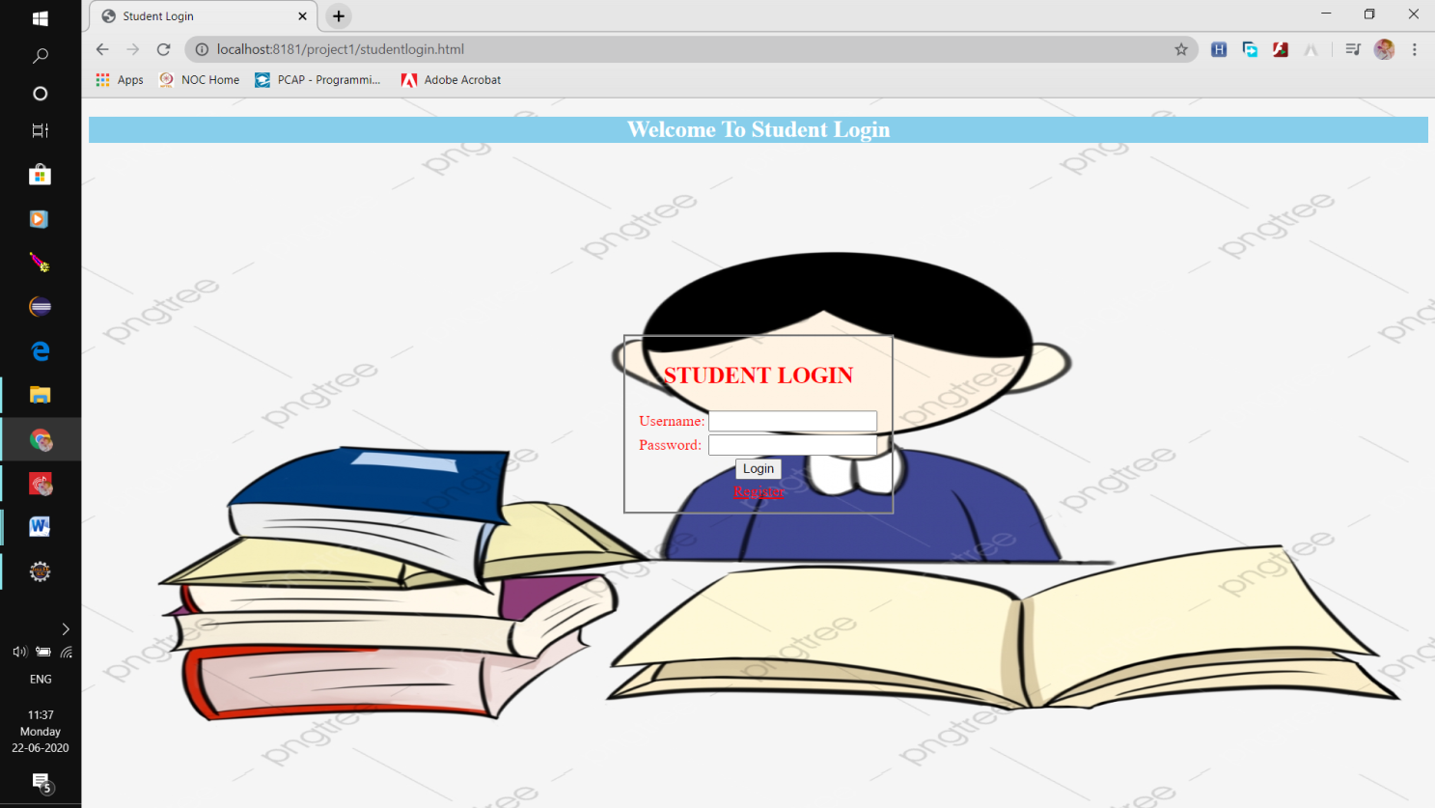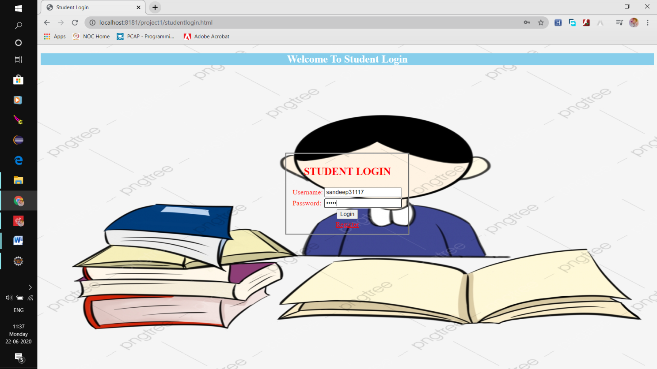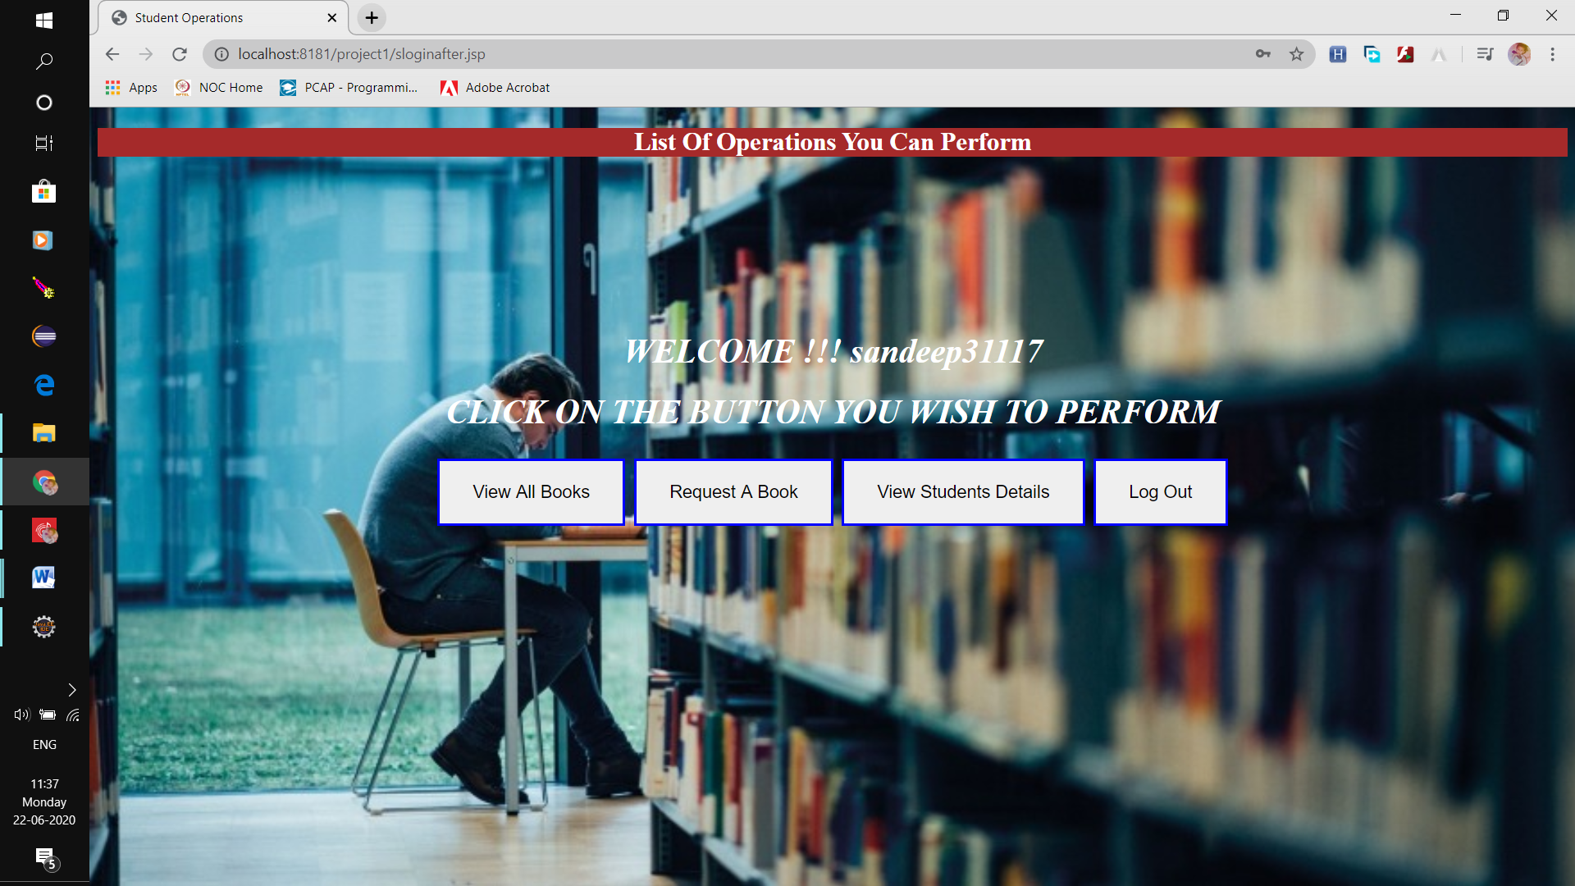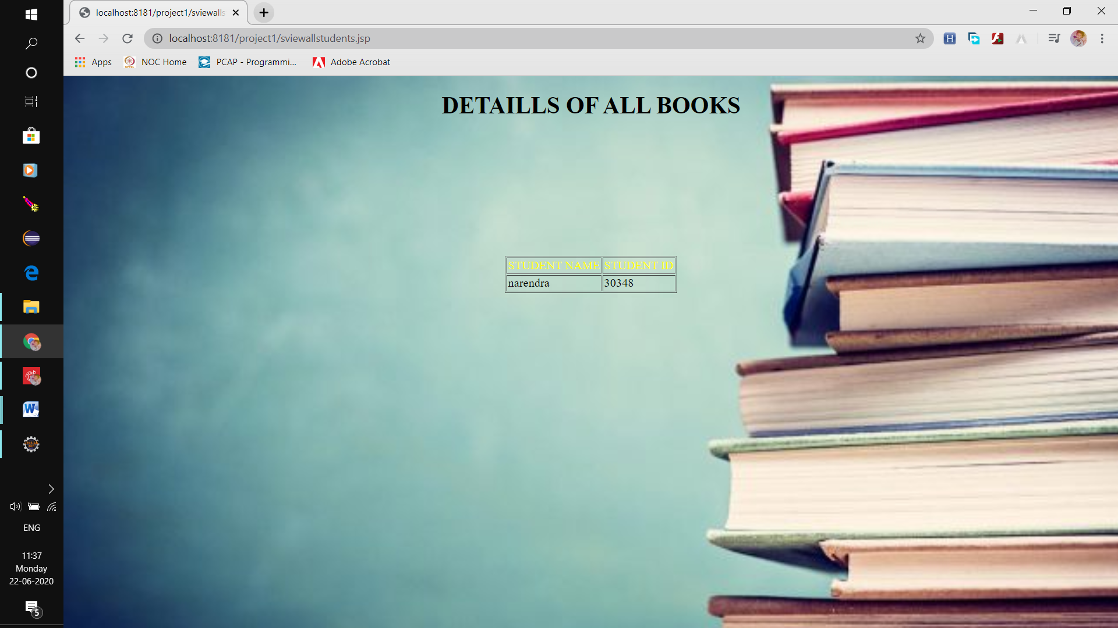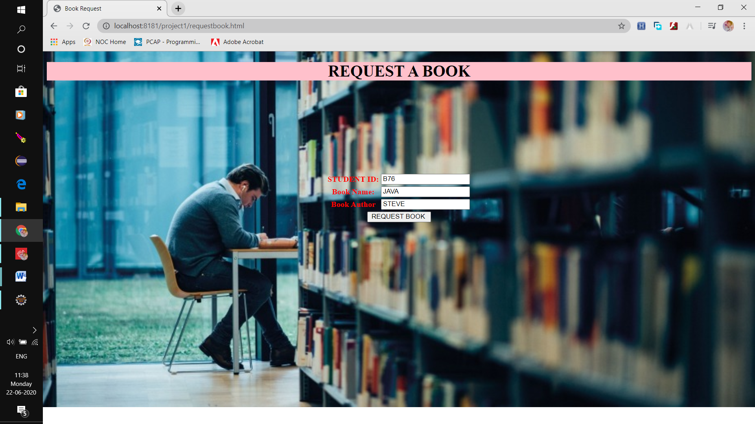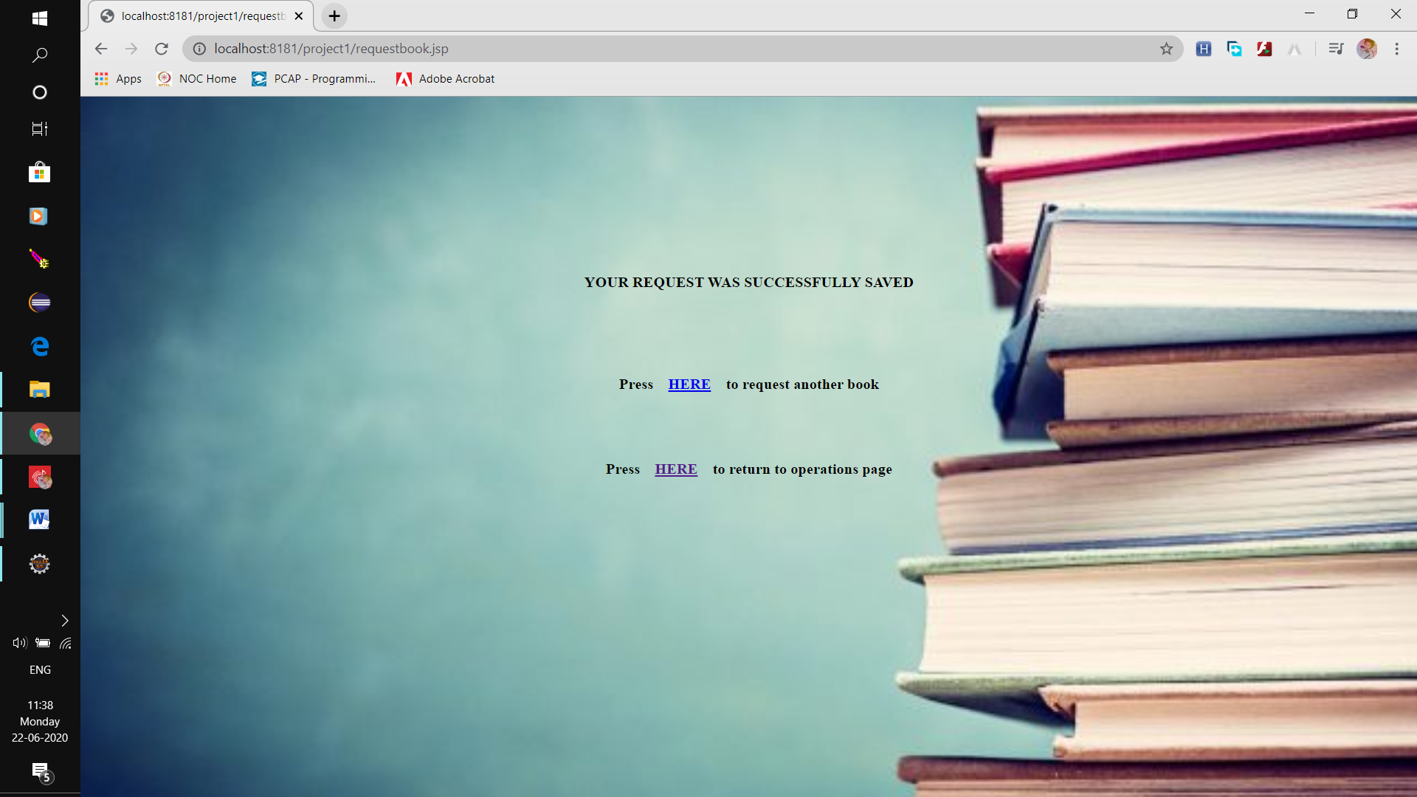

**CONCLUSION**

Our project is only a humble venture to satisfy the needs in a library. Several user friendly coding have also adopted. This package shall prove to be a powerful package in satisfying all the requirements of the organization

The objective of software planning is to provide a frame work that enables the manger to make reasonable estimates made within a limited time frame at the beginning of the software project and should be updated regularly as the project progresses. Last but not least it is no the work that played the ways to success.